GROUP PROCESSING / TREATMENT MAP
Select SQ products when possible.
Never give an injection in the rear leg or top butt.

Group:____________ Date:_____________ ID: Rt. Ear/ Lft Ear: ____________

Booster/Reprocess Date:_____________ Pen/Pasture #: ____________

Class: S / H / Bulls / Cows Age:_____ Weight:_________ Hd. Processed ________

Other Management (√): Castrate___ Dehorn ___ Other ___________ Crew _________

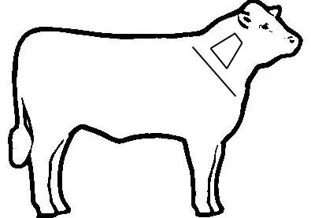
Right Left

Product and  Company | Lot or  Serial # | Exp.  Date | ROA* | Dose | Booster  Date | Withdrawal  Date
1.
2.
3.
4.
5.
6.
7.
8.
*ROA – Route of Administration

Comments:

Group:__________

Mass Medication
(Injectable, Feed, Water)

Group/Pen Record
Date | Medication | Serial/  Lot # | Dose | Dosage | Date Treatment Ended | Comments | WD*
*Withdrawal Date

Individual Treatment Record

(Within a Group)
I.D. | Date | Temp. | Diagnosis | Treatment/  Product | Serial/  Lot # | Dosage  Given | ROA/  Location | Date of Withdrawal | Proc.  Initials

Cattle Transfer Record
Number Received | Date Received | Number Shipped | Date Shipped | Shipped To | Withdrawal Check By

Notes:

Group:__________ Page______

Individual Treatment Record

(Within a Group)
I.D. | Date | Temp. | Diagnosis | Treatment/  Product | Serial/  Lot # | Dosage Given | ROA/  Location | Date of Withdrawal | Proc.  Initials

Group:__________

Mass Medication In Feed

Group/Pen Record
Date Started | Medication | Amount/  Ton | Projected  Intake | Projected  Dose/Head | Actual  Intake | Actual  Dose/Head | End of Feeding | Withdrawal  Date

Notes:

Cattle Transfer Record
(Group Record)

Group No. | Number Received | Date Received | Number Shipped | Date Shipped | Shipped To | Withdrawal Check By

Cattle Transfer Record
(Individual Record)

Individual I.D. # | Group Of Origin | Date Received | Date Shipped | Shipped To | Withdrawal Check By

Individual Treatment Record

Date | I.D. | Group | Temp. | Diagnosis | Treatment/  Product | Serial/  Lot # | Dosage  Given | ROA/  Location | Date of Withdrawal | Proc.  Initials | Comments

